**BMW**

[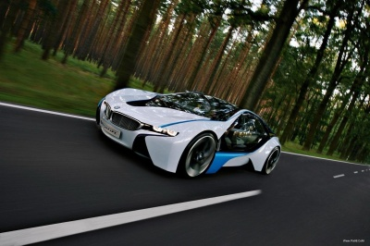](http://alimo.persiangig.com/bmw/show/Www.Pix98.CoM_011.jpg)

bmw vision

[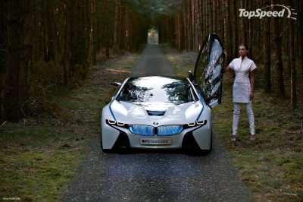](http://alimo.persiangig.com/bmw/show/Www.Pix98.CoM_012.jpg)

bmw vision

[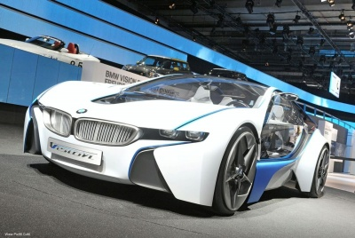](http://alimo.persiangig.com/bmw/show/Www.Pix98.CoM_013.jpg)

bmw vision

[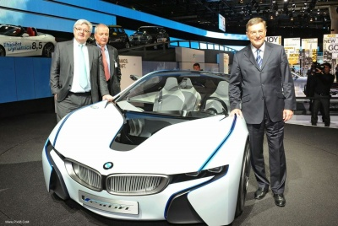](http://alimo.persiangig.com/bmw/show/Www.Pix98.CoM_014.jpg)

bmw vision

[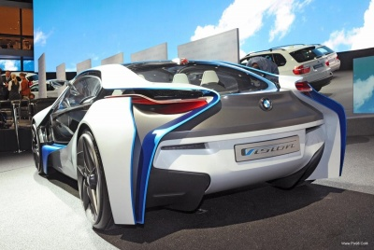](http://alimo.persiangig.com/bmw/show/Www.Pix98.CoM_015.jpg)

bmw vision

[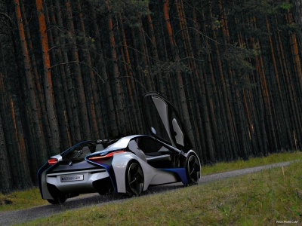](http://alimo.persiangig.com/bmw/show/Www.Pix98.CoM_016.jpg)

bmw vision

[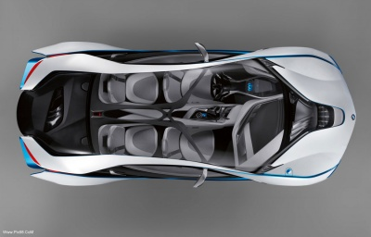](http://alimo.persiangig.com/bmw/show/Www.Pix98.CoM_017.jpg)

bmw vision

[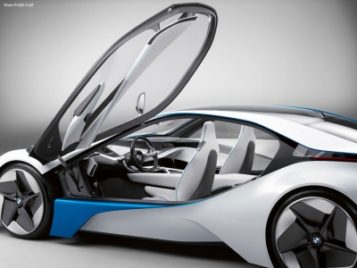](http://alimo.persiangig.com/bmw/show/Www.Pix98.CoM_018.jpg)

bmw vision

[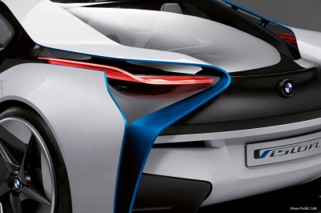](http://alimo.persiangig.com/bmw/show/Www.Pix98.CoM_019.jpg)

bmw vision

[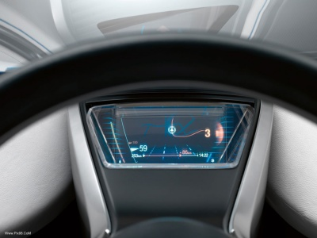](http://alimo.persiangig.com/bmw/show/Www.Pix98.CoM_020.jpg)

bmw vision

[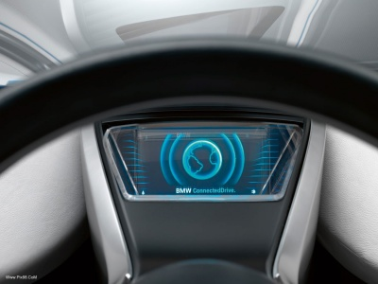](http://alimo.persiangig.com/bmw/show/Www.Pix98.CoM_021.jpg)

bmw vision

[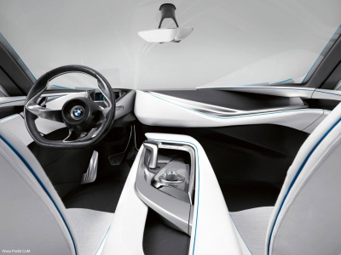](http://alimo.persiangig.com/bmw/show/Www.Pix98.CoM_022.jpg)

bmw vision